Cuernavaca Report
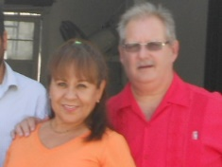
Dear Brethren,
We had a wonderful time during our visit in December. It was great seeing all of you once again. We feel so blessed to be able to work with such a group of Christians who realize the importance of fulfilling the commission we’ve been given (Mt. 28:20). We’re happy to be back in Cuernavaca, especially when the weather here is much more agreeable (70* today).
We’ve jumped back into the work here and are picking up where we left off. Reconnecting with some takes a bit of urging but we’re continuing to stay in contact with them. We’ve got a study going on Thursday in our home with a woman named Elle. She’s been quite receptive and is eager to know more of Gods’ word.
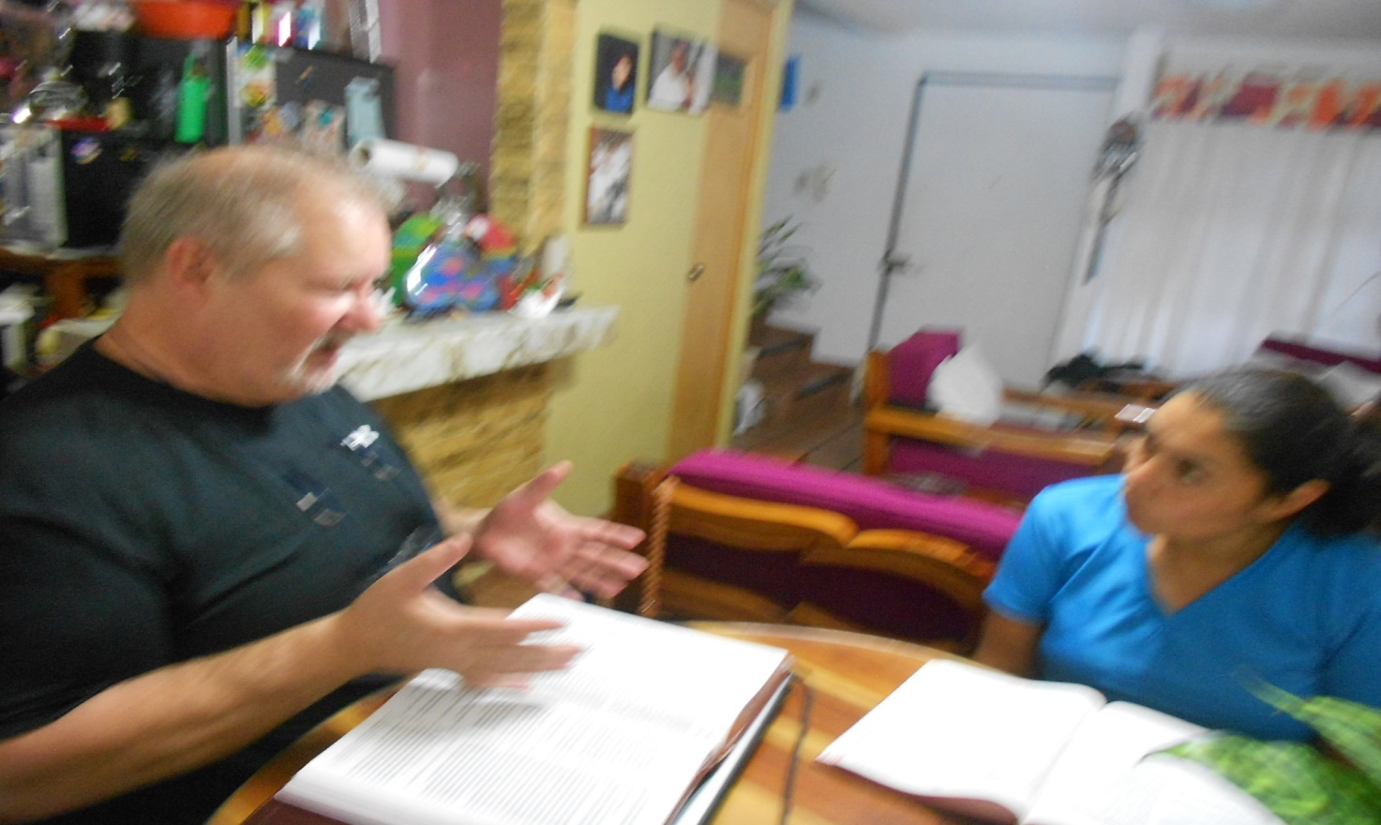
We’re continuing with the movie-night for the children of the neighborhood. Last Friday we showed a film about King David and they all seemed to enjoy it. Attendance was a little down due to lack of promotion. Once we returned from our trip we didn’t have adequate time to announce the movie in the community.
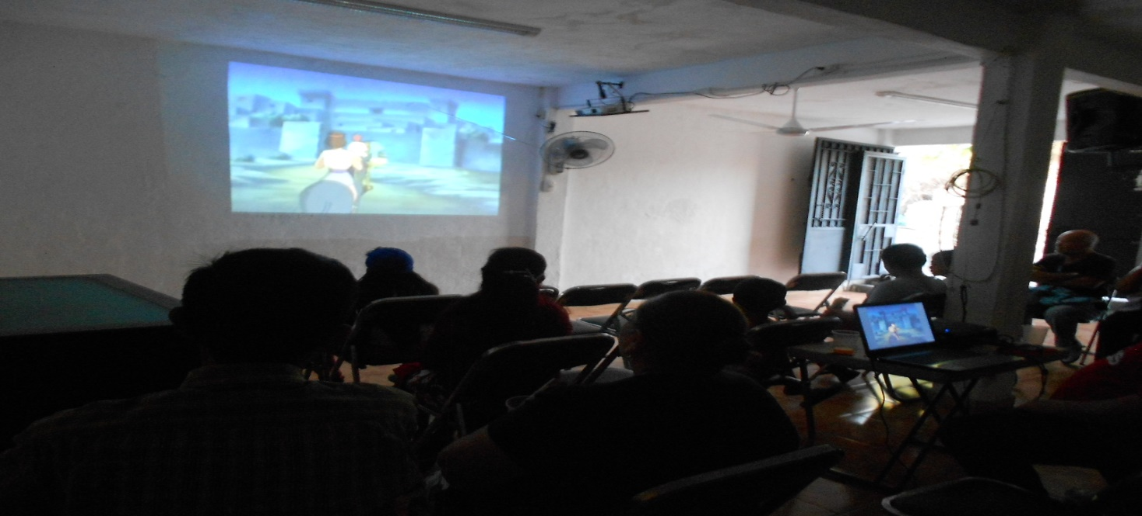
We appreciate your prayers and support for the work here. Without these things our ability to preach the gospel here wouldn’t be possible. We hope you see the value of your participation in expanding God’s kingdom here in Mexico. We’ve got a VBS planned for the last week of July. Springbrook is planning to participate in this event. If any of you are interested in coming to help with this please contact Neil Hodge at Springbrook for details. During our visit I had the opportunity to speak with Randy Sprague and he told me that he continues as Director of Delano Bay camp because he sees that He’s “making a difference in people’s lives”. I feel the same way concerning the work here, Thank you all for the opportunity you’ve providing us with to serve God in this manner. God Bless You, Ray Dennis
